Aborting a NetBurner Application
(Thanks goes to David Hazel for this!)

If you are having a problem terminating an application program that is running in Flash memory in your NetBurner, try the following:

- Bring up the IP Setup Tool. Click the “Advanced…” button:

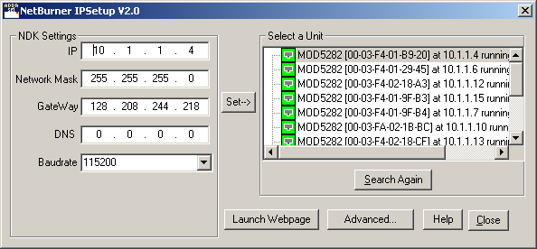

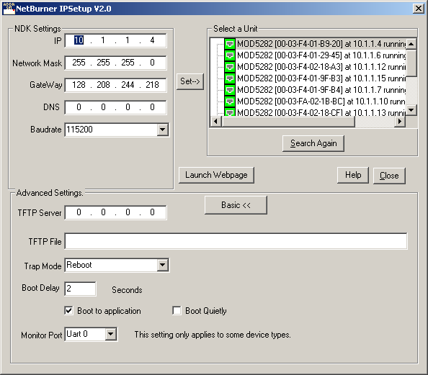

- Uncheck the “Boot to Application” box. Highlight *YOUR* NetBurner board connection, and click the “Set →” button. The NetBurner will now boot to the Monitor on reset or exception (if set to do this).

- You can now operate from the Monitor. :-)

- When you want to switch back to “Boot to Application” mode,
- go back the IP Setup Tool, check the “Boot to Application and ret YOUR NetBurner board again, or
- using the Multi-threaded TTY, from the Monitor HELP menu and the Setup menu, repeatedly enter “8” until “Boot to Application” is displayed. Then enter “s” to save the change, and enter “x” to exit.

